Introduction

This java swing project resulted with a simple hotel booking interface. The interface can perform several tasks, making it meet with the demands of basic reservation process.

GUI specifications

This interface contains a signal panel, putting all its features in a glance.

The GUI can be divided into three parts: customer information submission, room selecting with requirement stating and a picture attached on it that functions as a map.

Check in & out session as well as room selecting are designed to allow user import machine-friendly data, like separated strings of year, month and date.

It also comes with two more useful functions: a clear button at the end of text session, providing users with the ability to clear out all information they submitted if they have other ideas on booking. Additionally, a confirm button that leads to the payment page (not implemented as this is out of coursework requirement) is placed next to the clear button. Both buttons would have hits displayed under them if they are clicked.

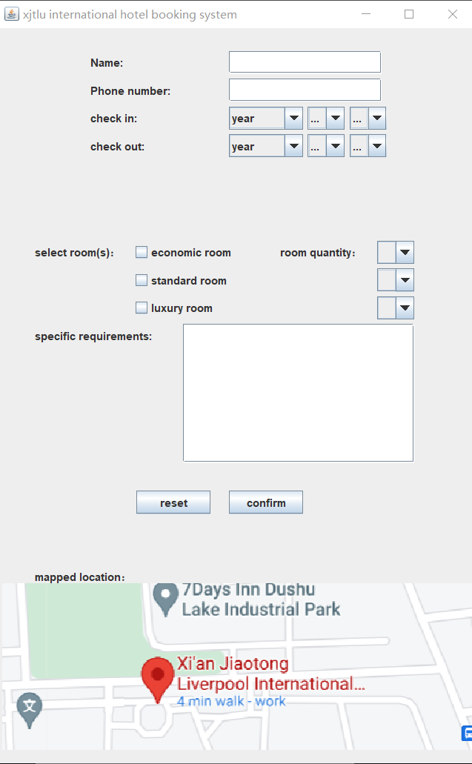

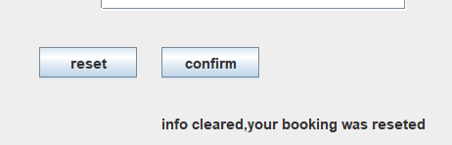

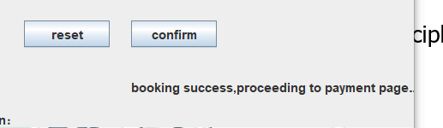

Principles implemented

The first design principles considered by the designer is simple and natural dialog. The interface only included 3 info slots for users to fill and other necessary information were all submitted by choosing. This makes the process easy and pleasurable.

Secondly, helps and feedbacks are presented as hints, displaying as defaults in the selecting window for check in and out as well as under the reset and confirm button, users will not get lost between year and month or don’t know what to expect.

Summery

This interface implemented major design principles and showed its designer’s understanding on java swing. It is usable but still have room to be improved.